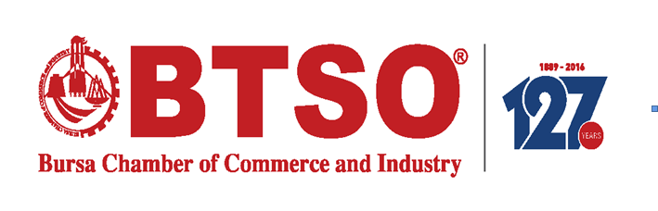

BURSA FOOD SECTOR BUYERS MISSION PROGRAM
27 SEPTEMBER – 01 OCTOBER 2017

27 SEPTEMBER 2017 – WEDNESDAY
Arrival to İstanbul and transfer to Bursa

28 SEPTEMBER 2017 – THURSDAY
Stand Visits/B2B Meetings (Place; Merinos Congress Center)
29 SEPTEMBER 2017 – FRIDAY
Stand Visits/B2B Meetings (Place; Merinos Congress Center)

30 SEPTEMBER 2017 – SATURDAY
City Tour/Factory Visits

01 OCTOBER 2017 – SUNDAY
Transfer from Bursa to Istanbul
Departure from Istanbul

