BURSA CHAMBER OF COMMERCE AND INDUSTRY
FOOD SECTOR BUYERS' MISSION PROGRAMME
27 SEPTEMBER – 1 OCTOBER 2017
COMPANY NAME
PARTICIPANT'S NAME(S) AND POSITION(S)
COMPANY ADDRESS
TEL/FAX
MOBILE
WEB SITE
E-MAIL
FLIGHT DESTINATION (From which city)  (Please send the copy of ID page of your passport for issuing flight ticket) | From …………………………………..…. to ISTANBUL  (İstanbul-Bursa transfers (1,5 hours) will be provided by ISTUR Tourism)
ESTABLISHMENT DATE OF THE COMPANY
TOTAL ANNUAL IMPORTS (USD)
BRIEF DESCRIPTION OF GOODS DEMANDED FROM TURKEY
STATUS OF THE COMPANY | Manufacturer  Manufacturer  Importer  Manufacturer  Importer  Manufacturer  Retailer  Manufacturer  Importer  Manufacturer  Retailer  Manufacturer  Importer  Manufacturer  Retailer  Manufacturer  Importer  Manufacturer  Retailer  Manufacturer  Importer  Manufacturer  Retailer  Manufacturer  Importer  Manufacturer  Retailer  Manufacturer  Importer  Manufacturer  Retailer  Manufacturer  Importer  Manufacturer  Retailer  Manufacturer  Importer  Manufacturer  Wholesaler  Manufacturer  Importer  Manufacturer  Retailer  Manufacturer  Importer  Manufacturer  Retailer  Manufacturer  Importer  Manufacturer  Retailer  Manufacturer  Importer  Manufacturer  Retailer  Manufacturer  Importer  Manufacturer  Retailer  Manufacturer  Importer  Manufacturer  Retailer  Manufacturer  Importer  Manufacturer  Retailer  Manufacturer  Importer  Manufacturer  Chain Store  Manufacturer  Importer  Manufacturer  Retailer  Manufacturer  Importer  Manufacturer  Retailer  Manufacturer  Importer  Manufacturer  Retailer  Manufacturer  Importer  Manufacturer  Retailer  Manufacturer  Importer  Manufacturer  Retailer  Manufacturer  Importer  Manufacturer  Retailer  Manufacturer  Importer  Manufacturer  Retailer  Manufacturer  Importer  Manufacturer  Other  (………………………………)  Manufacturer  Retailer  Manufacturer  Importer  Manufacturer  Retailer  Manufacturer  Importer  Manufacturer  Retailer  Manufacturer  Importer  Manufacturer  Retailer  Manufacturer  Importer  Manufacturer  Retailer  Manufacturer  Importer  Manufacturer
LANGUAGE(S) SPOKEN
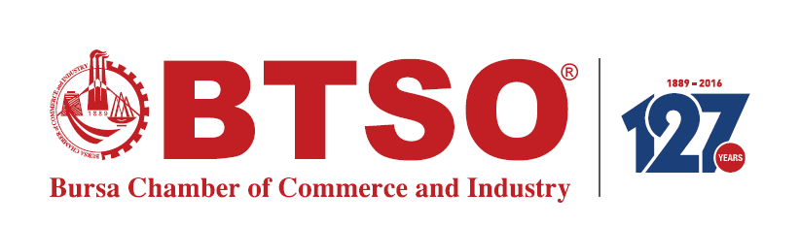
NOTE; Expenses will be covered maximum 2 people per company.

